Solution: Create New Objects with Popups

In the previous lab, you configured TrainingApp so that users can add, remove, and edit contact interactions on the Interactions page. Users can also navigate to the Interactions popup to view and edit the details of a contact interaction. However, users can only create new interactions in a new row of the list view panel.

In this lab, you will modify both the Interaction list view panel and the Interaction popup. You will modify the behavior of the Add button for the list view panel to navigate to the Interaction popup and create a new interaction object. You will also modify the Interaction popup to return the new interaction object to the list view panel when created by the user. Then, you will configure the popup and the list view panel navigable cell widgets so that the popup will be in the same mode as the list view panel.

Requirements

This lab requires that you use TrainingApp 8.0, Guidewire Studio 8.0, and a supported web browser. To view, edit, and delete various contacts, log in to TrainingApp as Alice Applegate. The default URL for TrainingApp is <http://localhost:8880/ab/ContactManager.do>. The login/password for Alice Applegate is aapplegate/gw.

1. Modify the Interaction Popup

In this exercise, you will modify the Interaction Popup to be able to create a new interaction object and return the new object to the Interaction list view panel. You will also modify the popup to start in edit mode for new objects. For existing objects that are already in edit mode from the source list view panel, you will configure the Popup to start in edit mode. For interaction objects already in read-only mode from the source list view panel, you will configure the Interaction Popup to remain in read-only mode.

Tasks

1. Open Guidewire Studio for TrainingApp
2. From Studio, if your server is not already running, start the server using Debug 'Server'.
3. Review the Debug console for errors and verify that the application is running in the Debug console.
4. Modify the InteractionPopup
5. Create an entry point that allows the popup to create a new interaction object in edit mode.  
   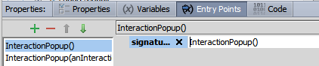
6. Configure the popup to create a new interaction object in edit mode and return that object to the Interaction list view panel.   
   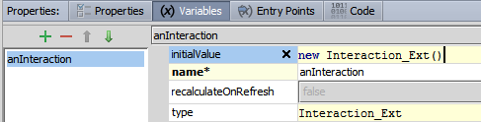  
   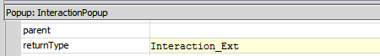  
   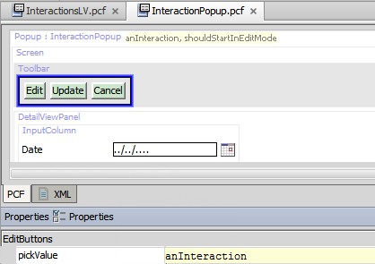
7. Configure the popup to start in edit mode for existing interactions objects that are already in edit mode and to start in read-only mode for existing objects that are already in read-only mode.  
     
   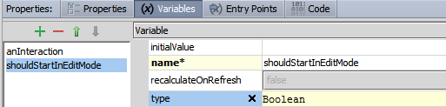

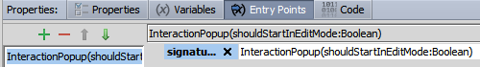  
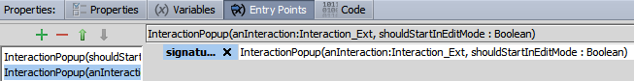  
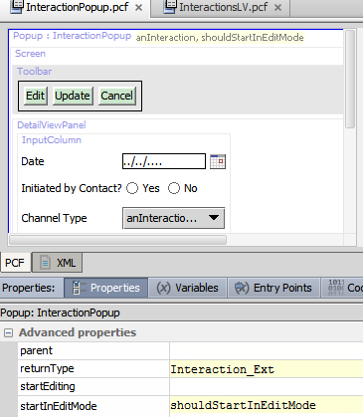

1. Modify the InteractionsLV
2. Configure the Add button to use the entry point that navigates to the Interaction Popup to create a new object in edit mode.  
   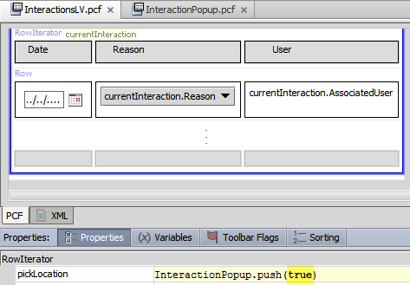
3. Configure the navigation cell widgets to be non-editable.
4. For when the InteractionsLV is in edit mode, configure the navigation cell widgets to navigate to the Interaction Popup and open the object in edit mode.
5. For when the InteractionsLV is in read-only mode, configure the navigation cell widgets to navigate to the Interaction Popup and open the object in read-only mode.  
   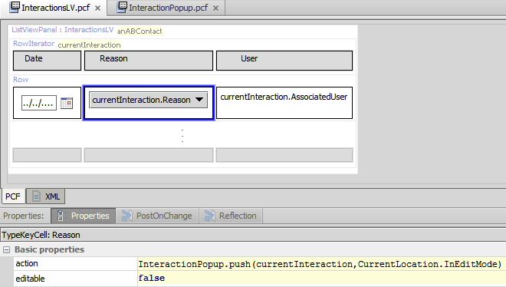

Verification

1. Log in to TrainingApp
2. Log in as Alice Applegate.
3. Reload the PCF changes
4. In TrainingApp, reload the PCF file changes.
5. View an existing interaction for William Andy
6. Open the William Andy contact.
7. In the sidebar menu, click Interactions.
8. Click a navigation cell widget for one of the rows in the list view panel that is in read-only mode.
9. View the details of an existing interaction in read-only mode in the popup.

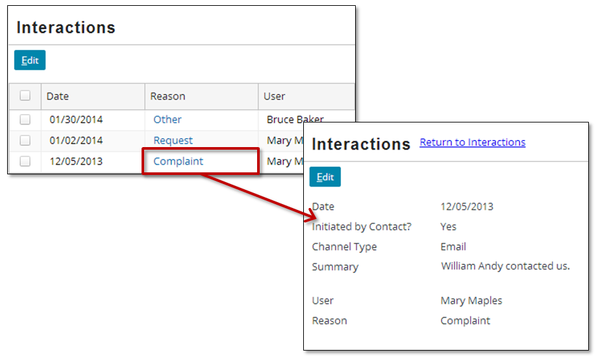

1. Edit an existing interaction for William Andy
2. In the sidebar menu, click Interactions.
3. Click Edit.
4. Click a navigation cell widget for one of the rows in the list view panel that is in edit mode.
5. Confirm that the popup is in edit mode already.
6. Edit the details of an existing interaction in the popup.
7. Click OK.
8. Click Update in the list view panel.
9. Verify that your changes are committed and visible in the list view panel.

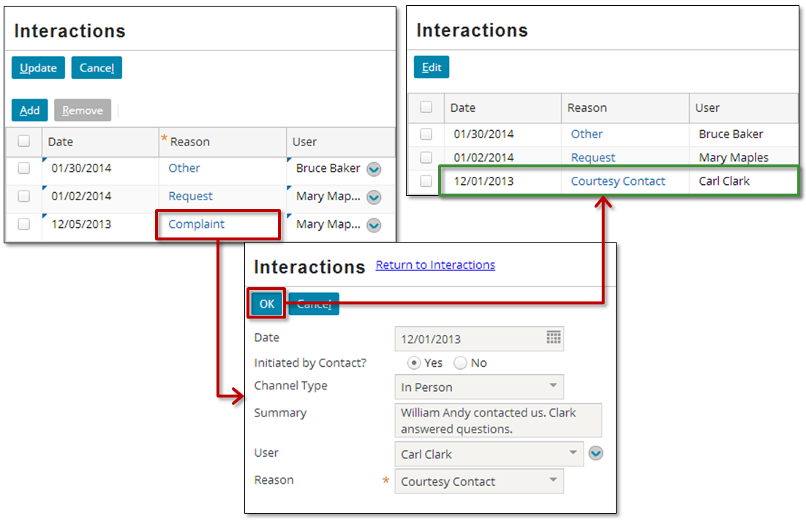

1. Create a new interaction for William Andy
2. In the sidebar menu, click Interactions.
3. Click Edit.
4. Click Add.
5. The popup should be in edit mode already and all fields should be blank.
6. Edit the details of a new interaction in the popup.
7. Click OK.
8. Click Update in the list view panel.
9. Verify that your changes are committed.

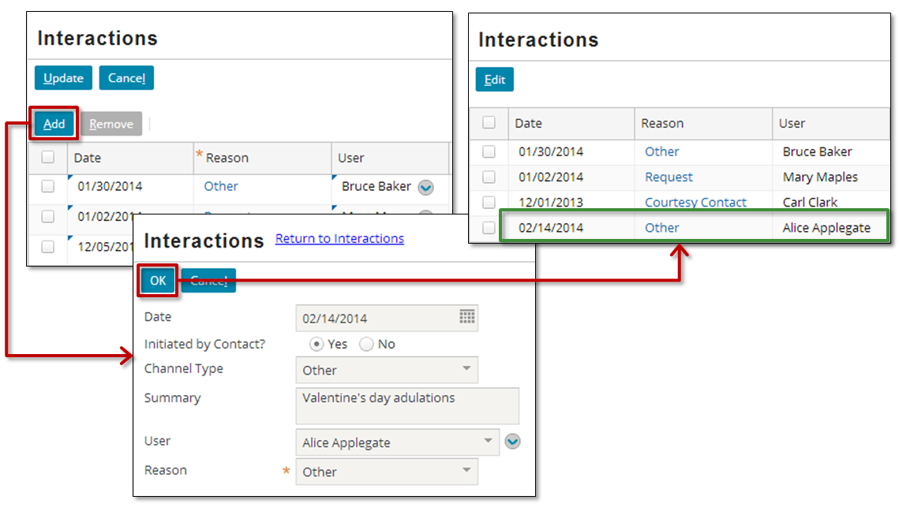

|  |  |
| --- | --- |
|  | Stop and ask your instructor to review your completed lab. |